## 

## 

## 

## 

## **Discourse in the South China Sea**

## 

## Ryan Skelly, Aurora Holland, Silan Gitterman

## CS 457: Intro to Data Science

## David Benedetto

## April 14, 2023

## 

## **Abstract**

## This Paper analyzes the data behind developing disputes in the South China Sea. We looked at ecosystems, sustainability in the sea itself, and happiness, economy, international conflicts, and military expenditure of bordering countries. Results for this study were inconclusive, although it is clear that growth in all countries involved has remained steady. Further diplomatic efforts are required to stabilize the region.

## **Introduction**

Our group project will be on the turbulent waters in the South China Sea. Off the coast of China, the Philippines, Vietnam, Thailand, Taiwan, Malaysia, and Indonesia, lies a few of the world’s most crucial and trafficked shipping lanes. These water highways are where the majority of the world's largest exporter’s goods are shipped, and if there were any problems at sea, the world economy would be hit the hardest. For a long time, the ownership of the South China Sea has been heavily disputed. China has been slowly building military islands for the strategic monitoring of trade and ensuring everything’s running smoothly, although some of its neighbors claim that they’re being constructed outside of China’s own country boundaries. Tensions are slowly rising in the region, and it’s only a matter of time before things escalate.

## **Research Questions**

1. What would happen to the marine ecosystems if China fully controlled the South China Sea? (Silan)

The South China Sea is a globally important marine ecosystem. It contains a lot of coral reeds, seagrass beds, and mangrove forests, which provide important habitats for fish, turtles, and other marine organisms. Increasing the shipping, oil, and gas drilling could have negative environmental consequences for marine ecosystems. The South China Sea is particularly vulnerable to climate change and ocean acidification. Ocean acidification is a process where CO2 in the atmosphere dissolves into seawater which releases a decrease in pH and an increase in acidity. This can have very negative effects on marine organisms. This includes the reduced ability to form and maintain shells, decreased growth and reproduction rates, and more. For research question 1, We looked at the measures of impact by examining data from nearby reefs and reefs affected by the dispute. This allowed me to create a graph comparing between different years and how reefs have been affected.

1. What effects does the dispute have on the conservation and sustainability in the region? (Silan)

The South China Sea dispute has major effects on the conservation and sustainability of the region. As I’ve mentioned before, if China gained control over the Sea, it would cause habitat destruction for marine organisms. Overfishing would also be a result of the dispute in the South China Sea. It has led to increased competition for fishery resources which could also result in unsustainable fishing practices. Increased shipping oil and gas drilling (as mentioned above) could lead to pollution, which would harm not only marine organisms but also threatens human health and impacts water quality. Climate change would also be a result of the South China Sea feud. Due to the fact that the South China Sea is vulnerable to climate change, the sea temperatures are rising, which results in ocean acidification and the destruction of coral reefs. This impacts not only the biodiversity in the area but also the food chain. For research question 2, We looked at cargo shipping from China to other countries and how it affects the conservation and sustainability of the region. This allowed be to create another graph showing the amount of cargo shipments over the years.

1. How has the overall happiness of China and the neighboring countries been affected over time by the disputes? (Aurora)

Looking at the overall happiness of the countries surrounding the South China Sea can explain the effect the recent disputes have on each country as a whole. Researching this question could help to indicate whether the disputes are affecting everyone in the country or just the politicians and military that are directly involved. A relatively unchanging happiness level could indicate either that the disputes are not concerning for civilians, or that civilians are not as aware of the tensions between the countries. For research question 3, We am looking at the happiness score from the World Happiness Report. We are looking at the maximum, minimum, and average happiness score for each country (China, Vietnam, Thailand, Taiwan, Malaysia, and Indonesia) over the time period from 2015-2022. We also made a chart comparing the happiness over time for each of the countries (fig. 1).

1. How have the disputes affected the economy of China and the neighboring countries? (Aurora)

Similarly to the change in happiness, a decreases in GDP could indicate that the shipping routes in the South China Sea are largely important to the overall economy of the countries. If the tensions in the area are having a large impact, it would likely show up as a decrease in the GDP of the surrounding countries. For research question 4, We am looking at the GDP from the World Happiness Report for each of the countries. We are looking at the maximum, minimum, and average GDP for each country from 2015-2019 as well as 2022. The GDP was collected as logged GDP for 2020 and 2021 and seemed to be calculated using a different formula, so We did not include it in my analysis. We also made a chart comparing the change in GDP over the above time span for each of the countries (fig. 2). We also looked at the correlation between GDP and Happiness Score by each year in order to see how the change in the overall economy affects the happiness of the region around the South China Sea (fig. 3).

1. Has the conflicts that occur each year increased?(Ryan)

The number of conflicts can generally be used to show how each country has been responding to China’s advancements and if it's becoming a more common occurrence. From initial research into the disputes, it's been stated that Japan, the US, and the UN have also been policing the Sea, which serves as more potential to gain insight into the dynamics of the region. An increase in conflicts could indicate China’s starting a more aggressive approach. A decrease could show that tensions are de-escalating, and that the surrounding countries are starting to regain control. For research question 5, We looked at occurrences of any conflict pertaining to the South China Sea based on country. This allowed me to create a frequency chart of where conflicts happened, and which region had the most amount of disturbance related to SCS.

1. Has the military expenditure of countries surrounding the region increased?(Ryan)

Military Expenditure per Country surrounding the SCS can be used to show how likely it is that a country suspects conflict arising in the near future. Militaries can also be used in civil conflicts, thus data could be skewed for different reasons, not pertaining to South China Sea disputes. An increase in any country could provide evidence of disputes if prior behaviors differed for the country in question. In addition to military expenditure, size of military, and also type of military(Like Naval) could also show preparation efforts For research question 6, We examined military expenditure per country. The SIPRWe database also gave me data in the form of total and per capita, which We chose to use both in separate charts.

**Visual Analysis & Interpretations**

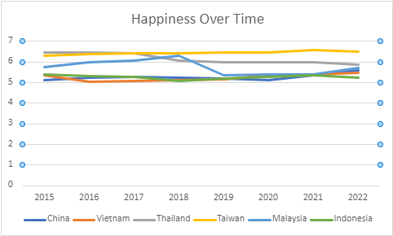

Fig. 1: Line Chart of Happiness Over Time

This chart shows me that most of the countries have relatively stable happiness scores from 2015-2022. Malaysia, which has a large coast bordering the South China Sea, has the most variability in the happiness scores, with an uptick in 2018 but a quick drop in 2019, with the 2022 score ending roughly the same as the score in 2015. China’s score increases the most overall from 2015 to 2022, while most other countries stay roughly the same. Thailand’s happiness significantly decreases from 2015 to 2022. This tells me that the disputes don’t seem to have had a major effect on the happiness of countries neighboring the South China Sea. The increase in China’s happiness could be related to their overtaking of the South China Sea, although it is not necessarily related. The lack of change in overall happiness of other countries could just be due to the lack of concern or involvement of normal citizens in the disputes.

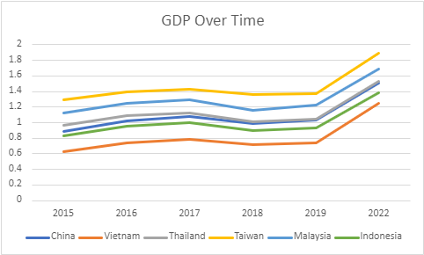

Fig. 2: Line Chart of GDP Over Time

This line chart shows that the GDP has increased for all 6 countries from 2015-2022, although the lack of data from 2020 and 2021 makes the increase look more dramatic. Looking at the lines from 2015-2019, each country moves in roughly the same way. This is interesting as it could indicate that the disputes are having the same affect on all the countries surrounding the South China Sea. There are slight differences in the the pattern of each country, however they do not seem to be significant when looking at the chart. The GDP’s of all the countries are significantly higher in 2022, which could indicate that the most recent disputes in the South China Sea are not having a negative affect on the GDP of the countries. This could mean that the South China Sea shipping routes are not a large enough portion of the GDP for it to show up, or that the affect is not yet determinable in the data we have available. It may show up in the coming years.

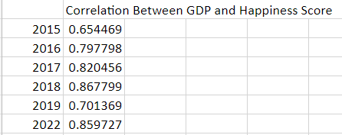

Fig. 3: Correlation Between GDP and Happiness Score

This chart shows that there is a pretty strong positive correlation between GDP and happiness score every year. The correlations do not change much from year to year. As GDP increases, happiness also increases. We can see from figure 1 and figure 2 that there are not many drastic changes in GDP or happiness over this time. Because of this, the correlations imply that there is a dependent relationship between GDP and happiness, so if the GDP of the region decreases, it is likely that happiness would also decrease. However, we can see an increase in the GDP in 2022 (fig. 2) for every country without seeing much increase in the happiness of the countries (fig. 1).

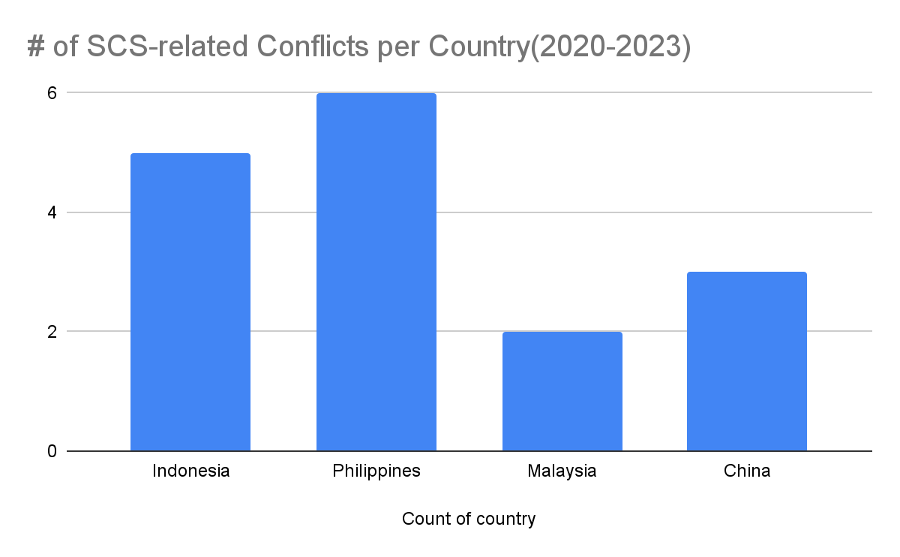

Fig. 4: # of SCS-related Conflicts per Country(2020-2023)

This chart shows the number of SCS-related conflicts in the target countries. As displayed by the graph, the majority of conflicts over the past three years have been in the Philippines. While each conflict is unique, one can take away that these conflicts are a result of the Philippines being the closest in a geographic location to the Spratly Islands. This is where the majority of intercountry-specific conflicts are occurring. The Spratly Islands are the most disputed region of the South China Sea, so it makes sense to have the largest number of disputes.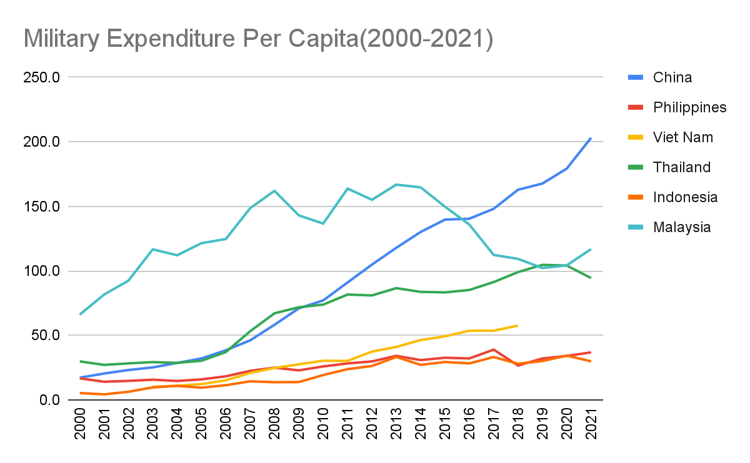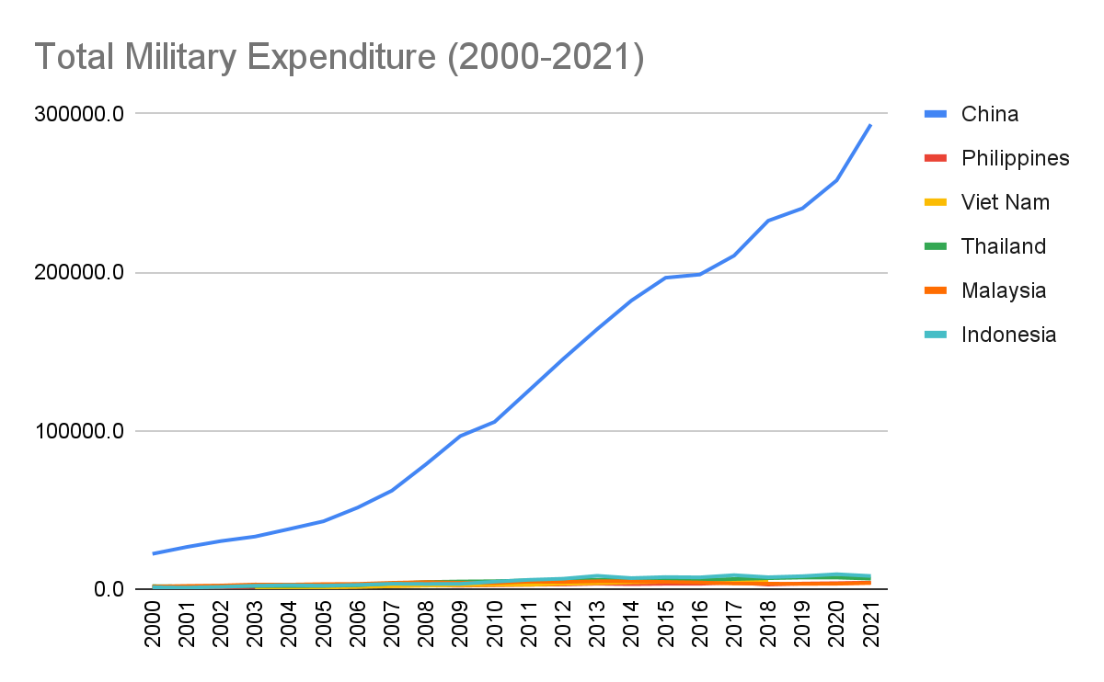

Fig. 5, 6: Military Expenditure Per Capita, Total Military Expenditure(2000-2021)

These two charts show Military Expenditure, in totality as well as per capita. Due to the size and population of China, China ranks the highest as of 2021, which has likely continued to the present day. This isn’t surprising although, between the two charts, it's clear to see that per capita is a better visualization, as it's easier to distinguish rankings. Due to the localization of the Philippines, It is concerning that they have the second lowest Expenditure per capita, while being the closest to the Spratly Islands. As China has a total expenditure that dwarfs all other surrounding countries in comparison, its clear if conflict were ever to arise, it’d be hard for single countries to stand in opposition to their demands/advances.

Fig. 7: Monthly average of backscatter near Mischief Reef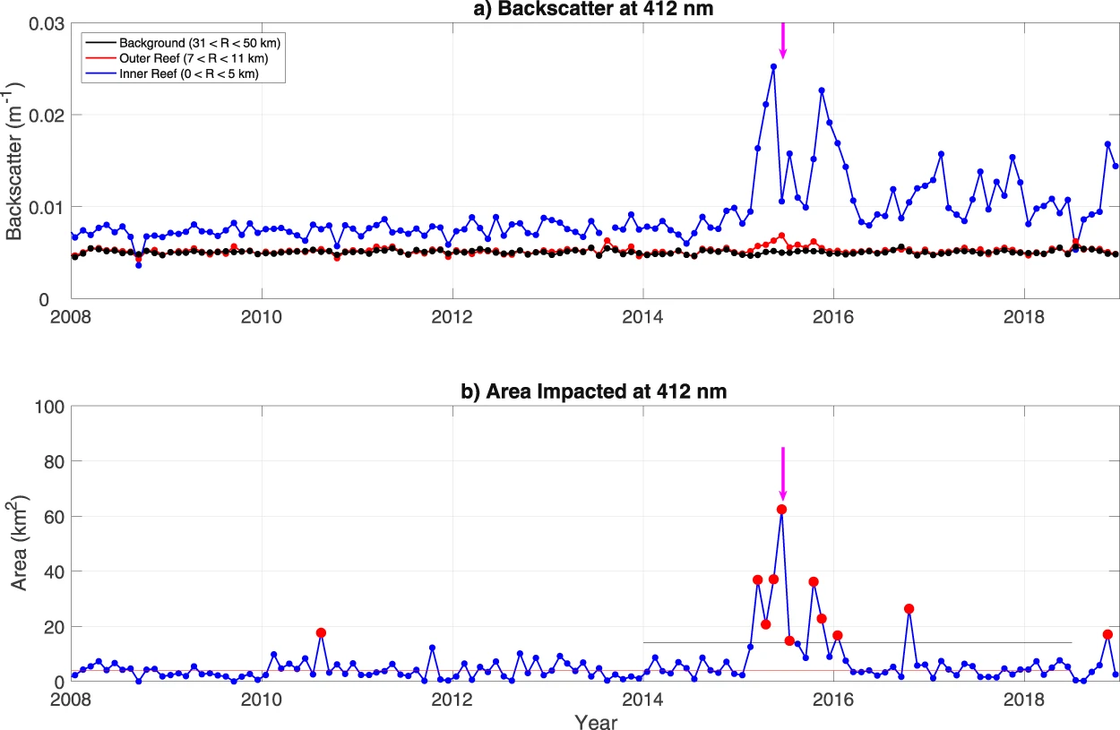

This chart shows the reflection of waves back to the direction they came from. The curves for the pre-dredging years are statistically very similar to each other indicating a stable environment. This changes dramatically for backscatter starting in 2015, with a mean backscatter within the reef increasing by a factor of 3 in 2015 over the pre-2015 level and decaying away from the reef to the background level at a radial distance of 10 km. The relatively small increase in the outer reef area compared to that within the reef is not surprising given that the inner reef area is shallow and nearly enclosed compared to the outer reef area, which is in the open ocean, hence dredged sediments in the water column in the inner reef are not likely to disperse as quickly. In the years (2016–2018) following dredging, backscatter within the reef drops to about twice the pre-2015 level, with little change over the three years, and it falls to the pre-2015 levels immediately outside of the reef.

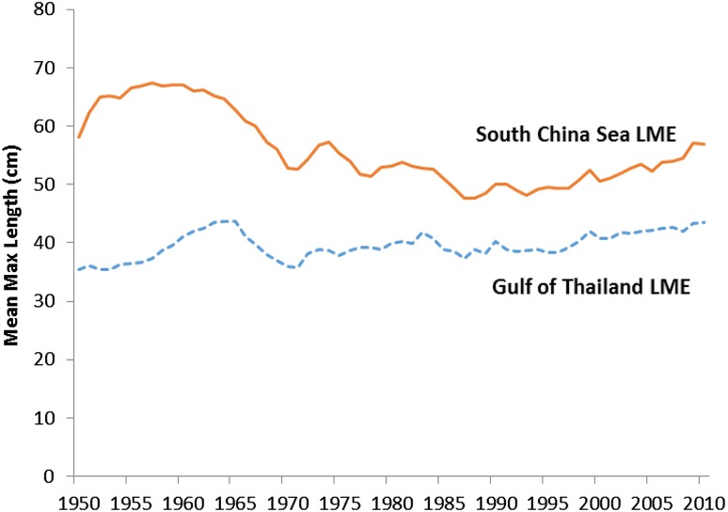

Fig.8: Mean and max length of catches in the GOT and SCS.

This graph shows that the ML declined substantially in the mid-1960s as the region’s fisheries became increasingly overexploited following rapid expansion of the industrial fishing sector. The lowest level was reached in the mid-1970s for the Gulf of Thailand LME, and mid-1980s for the SCS LME, after which the mean maximum length remained fairly stable, with slight increases since 2000 in both LMEs. The loss of large predatory species can affect ecosystem structure, function, and resilience, with resulting socio-economic and management consequences. Cascading effects, wherein the decrease in predator abundance leads to an explosion in their prey population, can shift the socio-economic dynamics of the fishery, and also increase variability and instability in the system, thereby posing substantial challenges for fisheries management (What is at stake).

## **Discussion**

In his article “Will the South China Sea Spark the Next Global Conflict?”, Richard Javad Heydarian says that “although China is set to overtake the United States as the world’s largest economy later this decade, the wealth of its average citizen, the strength of its educational institutions, and its overall stockpile of strategic resources are far behind those of its Western rivals” (Heydarian, 2021). We can see the trajectory of the GDP of China in fig. 2. The economy is clearly growing over time, especially when looking at 2019 versus 2022. The economic power of the South China Sea cannot be understated as an important factor in this increase in the GDP of China. However, this increase does not seem to be making its way down to the regular citizens. One direction for possible further research would be to look at how this economic growth is being used in the country.

Heydarian also says, “as if things weren’t dramatic enough, Malaysia, another active claimant in the South China Sea, triggered a three-way naval showdown with both China and Vietnam after its late-2019 decision to unilaterally explore energy resources in its continental shelf” (Heydarian, 2021). This conflict could explain the dramatic decrease in happiness score of Malaysia from 2018 to 2019. The happiness score then remains low through 2022. It seems likely that since Malaysia was engaged in conflict beginning in late 2019, the country as a whole was seeing the effects of the tension through the overall happiness of its citizens.

According to a recent Newsweek article, China's maritime militia has been spotted swarming a Philippine-held island in the South China Sea, raising concerns about China's aggressive actions in the disputed waters. The Philippine military has reported that around 240 Chinese boats, mostly from the maritime militia, have been seen around Pag-asa Island, highlighting the ongoing tensions in the region. China has been increasing its military presence and asserting its territorial claims over most of the South China Sea, despite opposition from other claimants such as the Philippines, Vietnam, Malaysia, Brunei, and Taiwan. The Spratly Islands, the most disputed region in the area, are located near the Philippines, and this has made it a frequent location of South China Sea-related conflicts. This incident underscores the need for diplomatic efforts to resolve the territorial disputes in the South China Sea.

## **Conclusion**

Overall, the happiness of the countries around the South China Sea (China, Vietnam, Thailand, Taiwan, Malaysia, and Indonesia) remain relatively unchanged. Malaysia displays the most variability in happiness over the time period. Since Malaysia shares a large coast with the South China Sea, the severe drop in happiness between 2018 and 2019 could very well be related to issues in the region. The GDP of each country moves at roughly the same rate and pattern, with only small differences. This could indicate that the effect disputes in the area are having on the shipping routes in the South China Sea are showing up equally for all of the surrounding countries. It is also possible that the effects of the most recent disputes are not yet visible in the data from the World Happiness Reports that are currently available. It is probably likely that we will see a change in the overall GDP of these countries in the coming years as military tensions continue to rise and conflicts increase. The strong positive correlation between GDP and happiness each year indicates that if these military conflicts affect either one of these variables, it will have the same effect on the other one. We believe that military tensions will continue to increase and that it will have a negative effect on the GDP, as the South China Sea is a major shipping hub. This will likely bring down the happiness of the countries, whether it be from the actual conflicts or simply because the economy is suffering. `

From military expenditure analysis, and frequency of conflicts, it’s still unclear whether tensions are truly rising. China will likely remain the largest investor in homeland military in the region, and due to the Philippines being closely located in the Spratly Islands, the amount of conflicts will likely stay the same. Data does clearly show that China is a financial powerhouse in the region, and cannot be directly challenged by one country individually. If with future data, its shown that a large number of conflicts have been situated in the Philippines, then it could be an accurate assumption that tensions are continuing to rise. Also, if other countries show a large jump in military expenditure, then it’d also be right to assume that they’re plotting for opposition to China. The Country most pertinent to these disputes is by far the Philippines, and is the best location to get data to gauge whether conflicts are rising or not. While not featured in our analysis, Legislation reports could also be good indicators of disruption. Progress in the region could be shown in de-escalation, a decrease in conflicts pertaining to the SCS, and lower Chinese Military Expenditure.

The article by Heydarian highlights the growing economic power of China, but also notes that the benefits of this growth do not seem to be reaching the regular citizens. The South China Sea is an important factor in this economic growth, but it has also been a source of conflict, as seen with Malaysia's decision to explore energy resources in the area. This conflict may have contributed to the decrease in the happiness score of Malaysia's citizens. Additionally, recent reports of China's maritime militia swarming a Philippine-held island in the South China Sea highlight the ongoing tensions in the region and the need for diplomatic efforts to resolve the territorial disputes. Further research is needed to understand how the economic growth is being used in China and its impact on the citizens.

All in all, our group found that there were no significant indicators that showed tensions rising in the South China Sea. With more data, and a larger time frame, further changes in data could happen, although the minor incremental changes weren’t enough to forecast immediate discourse. The turbulence of the region is showing some amount of change by recent events, and could become more drastic over time. Additional Analytical work on more factors could show a difference in outcome. It is wise to keep a close eye on the Spratly Islands, and trade disruptions, as the South China Sea is crucial to world infrastructures.

## **Works Cited**

Heydarian, R. J. (n.d.). Will the south china sea spark the next global conflict? *Diplomat Magazine*.

<https://www.viet-studies.net/kinhte/SCSGlobalConflict_Diplo.pdf>

Chang, G. (2023, March 8). China's Maritime Militia Swarms Philippine-Held Island in South China Sea. Newsweek.

<https://www.newsweek.com/chinas-maritime-militia-swarms-philippine-held-island-south-china-sea-1681424>

Sustainable Development Solutions Network. (n.d.). *World happiness report*. Kaggle.

<https://www.kaggle.com/datasets/unsdsn/world-happiness?select=2015.csv>

Sustainable Development Solutions Network. (n.d.). *World happiness report*. Kaggle.

<https://www.kaggle.com/datasets/unsdsn/world-happiness?select=2016.csv>

Sustainable Development Solutions Network. (n.d.). *World happiness report*. Kaggle.

<https://www.kaggle.com/datasets/unsdsn/world-happiness?select=2017.csv>

Sustainable Development Solutions Network. (n.d.). *World happiness report*. Kaggle.

<https://www.kaggle.com/datasets/unsdsn/world-happiness?select=2018.csv>

Sustainable Development Network Solutions. (n.d.). *World happiness report*. Kaggle.

<https://www.kaggle.com/datasets/unsdsn/world-happiness?select=2019.csv>

Londeen, M. (n.d.). *World happiness report 2020*. Kaggle.

<https://www.kaggle.com/datasets/londeen/world-happiness-report-2020>

Singh, A. (n.d.). *World happiness report 2021*. Kaggle.

<https://www.kaggle.com/datasets/ajaypalsinghlo/world-happiness-report-2021>:

Singh, A. (n.d.). *World happiness report 2022*. Kaggle.

<https://www.kaggle.com/datasets/ajaypalsinghlo/world-happiness-report-2022>

Armed Conflict Location & Event Data Project. (n.d.). ACLED Data Export Tool.

Retrieved March 11, 2023, from <https://acleddata.com/data-export-tool/>

Stockholm International Peace Research Institute. (n.d.). SIPRI Military Expenditure Database.

Retrieved March 11, 2023, from <https://milex.sipri.org/sipri>

Smith, L., Cornillon, P., Rudnickas, D., & Mouw, C. B. (2019, March 28). Evidence of environmental changes caused by Chinese island-building. Nature News. Retrieved April 1, 2023, from <https://www.nature.com/articles/s41598-019-41659-3#citeas>

**Appendix A**

Authors of each paragraph:

Aurora: 5, 6, 9, 10, 11, 16, 17

Ryan: 1, 2, 7, 8, 12, 13, 18, 19

Silan: 3, 4, 14, 15

Spreadsheet with data and analysis for RQ3 and RQ4: [World Happiness Report Spreadsheet](https://universitysystemnh-my.sharepoint.com/:x:/r/personal/ajh1163_usnh_edu/_layouts/15/Doc.aspx?sourcedoc=%7BEA72D3B3-3294-4050-9C7D-20E0A2F217DD%7D&file=World%20Happiness%20Report.xlsx&action=default&mobileredirect=true&DefaultItemOpen=1&login_hint=ajh1163%40usnh.edu&ct=1678409037090&wdOrigin=OFFICECOM-WEB.START.REC&cid=22b9b33d-a079-4873-bb47-5eeb60f58215)

Spreadsheet with data and analysis for RQ5 and RQ6: [South China Sea Datasheet](https://docs.google.com/spreadsheets/d/1kFCOEHHUP3_D__2T1PEiARtVq-llvvl_qLk7Yvn5OUc/edit?usp=sharing)